**PIZZA SALES SQL QUERIES**

**A. KPI’s**

**1. Total Revenue:**

**Query -SELECT SUM (total_price) AS Total_revenue FROM pizza_sales;**

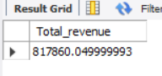

**2. Average Order Value**

**Query -SELECT SUM(total_price)/COUNT(DISTINCT order_id) AS avg_order_value FROM pizza_sales;**

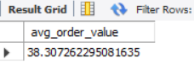

**3. Total Pizzas Sold**

**Query -SELECT SUM(quantity) AS Total_pizzas_sold FROM pizza_sales;**

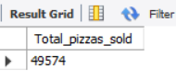

**4. Total Orders**

**Query -SELECT COUNT(DISTINCT order_id) AS total_orders FROM pizza_sales;**

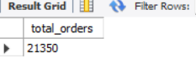

**5. Average Pizzas Per Order**

**Query -SELECT SUM(quantity)/COUNT(DISTINCT order_id) AS avg_order_value FROM pizza_sales;**

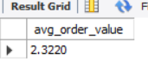

**B. Hourly Trend for Total Pizzas Sold**

**Query -SELECT HOUR(order_time) AS order_hour,SUM(quantity) AS total_pizzas_sold FROM pizza_sales GROUP BY order_hour;**

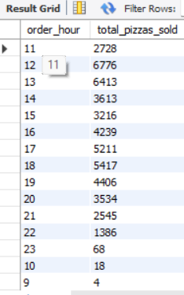

**C. Weekly Trend for Orders**

**D. % of Sales by Pizza Category**

**Query-SELECT pizza_category,(SUM(total_price) * 100 / (SELECT SUM(total_price) FROM pizza_sales))AS Total_sales_in_percent FROM pizza_sales GROUP BY pizza_category;**

***Output***

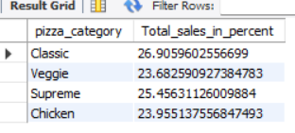

**E. % of Sales by Pizza Size**

**Query-SELECT pizza_size,(SUM(total_price) * 100 / (SELECT SUM(total_price) FROM pizza_sales))AS Total_sales_in_percent FROM pizza_sales GROUP BY pizza_size;**

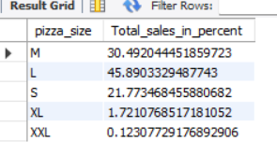

**F. Total Pizzas Sold by Pizza Category**

**Query-SELECT pizza_category,SUM(quantity)AS Total_pizzas_sold FROM pizza_sales GROUP BY pizza_category;**

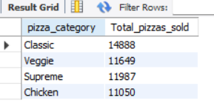

**G. Top 5 Pizzas by Revenue**

**Query-SELECT DISTINCT(pizza_name)AS pizza_name,SUM(total_price)AS Total_revenue FROM pizza_sales GROUP BY pizza_name ORDER BY Total_revenue DESC LIMIT 5;**

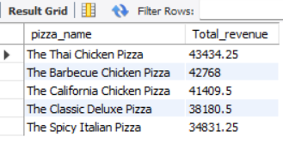

**H. Bottom 5 Pizzas by Revenue**

**Query-SELECT DISTINCT(pizza_name)AS pizza_name,SUM(total_price)AS Total_revenue FROM pizza_sales GROUP BY pizza_name ORDER BY Total_revenue LIMIT 5;**

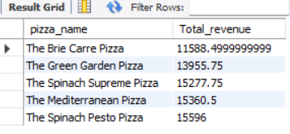

**I. Top 5 Pizzas by Quantity**

**Query-SELECT DISTINCT(pizza_name)AS pizza_name,SUM(quantity)AS total_pizzas_sold FROM pizza_sales GROUP BY pizza_name ORDER BY Total_pizzas_sold DESC LIMIT 5;**

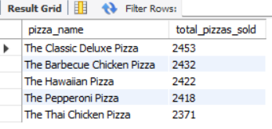

**J. Bottom 5 Pizzas by Quantity**

**Query-SELECT DISTINCT(pizza_name)AS pizza_name,SUM(quantity)AS total_pizzas_sold FROM pizza_sales GROUP BY pizza_name ORDER BY Total_pizzas_sold LIMIT 5;**

***Output***

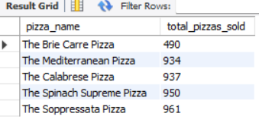

**K. Top 5 Pizzas by Total Orders**

**Query-SELECT DISTINCT(pizza_name)AS pizza_name,COUNT(DISTINCT order_id)AS Total_orders FROM pizza_sales GROUP BY pizza_name ORDER BY Total_orders DESC LIMIT 5;**

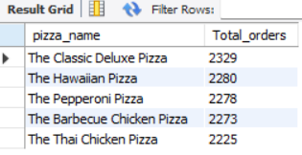

**L. Borrom 5 Pizzas by Total Orders**

***Query- SELECT DISTINCT(pizza_name)AS pizza_name,COUNT(DISTINCT order_id)AS Total_orders FROM pizza_sales GROUP BY pizza_name ORDER BY Total_orders LIMIT 5;***

